Joystick Piloting Lunar Loop Test Rev 0 issued 14th. March 2021 by Jørn Watvedt as rough draft.

Generally, our “tests” are a formal performance framework that we hope the RC boat community and the Open Source ArduPilot community find sufficiently challenging to help us advance this technology. Our dream scenario is that the RC community start hosting RC boat competitions based on our tests. About time to start competing in other disciplines that brute speed!

Objective of this test is to quickly determine how far in the development process the autopilot has advanced, since a perfect score require a perfect system for engine vectoring, gps, compass and gyro.

Unit = Radius, which may be 1 meter or 2 meter or 20 meter or whatever.

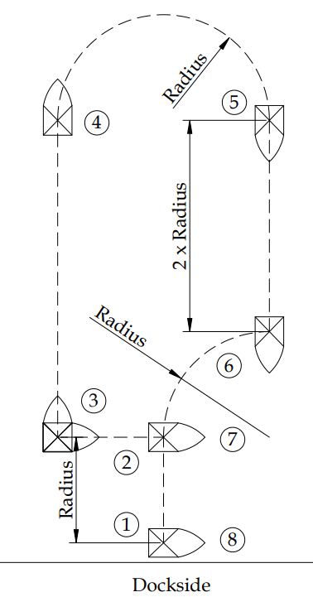

Pos.1: Starting with cold dead electronic at the dockside

Pos. 1 to 2: Sideways port side shift at fixed speed.

Pos 2 to 3: Backward movement

Pos 3: Stationary counterclockwise 90 dgr. Rotation of center of gravity GOC

Pos. 3 to 4: Speed jump max acceleration to max braking power to low speed at Pos. 4

Pos 4 to 5: Controlled turn to a fixed radius, controlling boat rotation thru the curve at low speed.

Pos 5 to 6: Speed ramp: Ramp up to fixed high speed, hold speed steady, ramp down to standstill.

Pos. 6 to 7: Starboard arc radius at fixed arching speed.

Pos. 7 to 8: Sideways starboard side shift at fixed speed.